**1)**

Query:

SELECT D.country as country_name,

COUNT(A.customer_id) as customer_count

FROM customer A

INNER JOIN address B ON A.address_id = B.address_id

INNER JOIN city C ON B.city_id = C.city_id

INNER JOIN country D ON C.country_id = D.country_id

GROUP BY D.country

ORDER BY COUNT(A.*) DESC

LIMIT 10;

output:

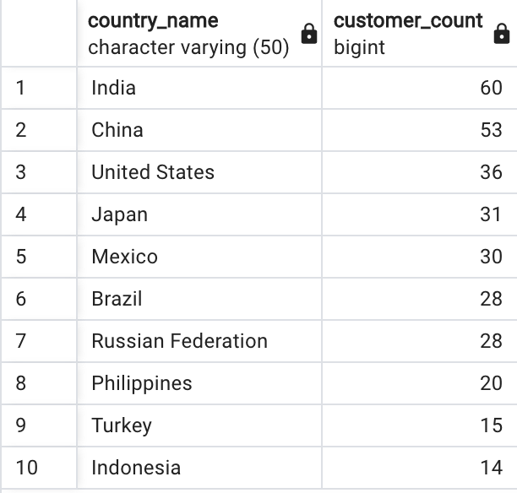

thoughts:

⇒ First, I examined the ERD to determine which tables I required.

⇒ I started writing the INNER JOINS to be able to access the data I need

⇒ than I SELECTED the data I need and ordered/grouped/limited it

**2)**

Query:

SELECT C.city,

COUNT(A.customer_id)

FROM customer A

INNER JOIN address B ON A.address_id = B.address_id

INNER JOIN city C ON B.city_id = C.city_id

INNER JOIN country D ON C.country_id = D.country_id

WHERE country IN ('India', 'China', 'United States', 'Japan', 'Mexico', 'Brazil', 'Russian Federation', 'Philippines', 'Turkey', 'Indonesia')

GROUP BY city

ORDER BY count DESC

LIMIT 10;

output:

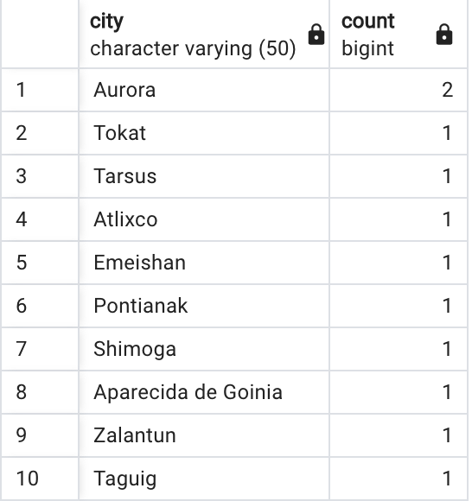

thoughts:

⇒ This time I used the result from question number one and used them inside the IN statement

⇒ There is no top 10 because just two cities have a customer count greater than one and several have a count of one. I'd just like to point out that the customer count in London and Aurora is greater than usual.

**3)**

Query:

SELECT

A.customer_id,

A.first_name,

A.last_name,

D.country as country_name,

C.city,

SUM(E.amount) as total_amount_paid

FROM customer A

INNER JOIN address B ON A.address_id = B.address_id

INNER JOIN city C ON B.city_id = C.city_id

INNER JOIN country D ON C.country_id = D.country_id

INNER JOIN payment E ON A.customer_id = E.customer_id

WHERE city IN ('Aurora', 'Tokat', 'Tarsus', 'Altixco', 'Emeishan', 'Pontainak', 'Shimoga', 'Aparaceida de Goiania', 'Zalantun', 'Taguig')

GROUP BY

A.customer_id,

D.country,

C.city

ORDER BY total_amount_paid DESC

LIMIT 5;

output:

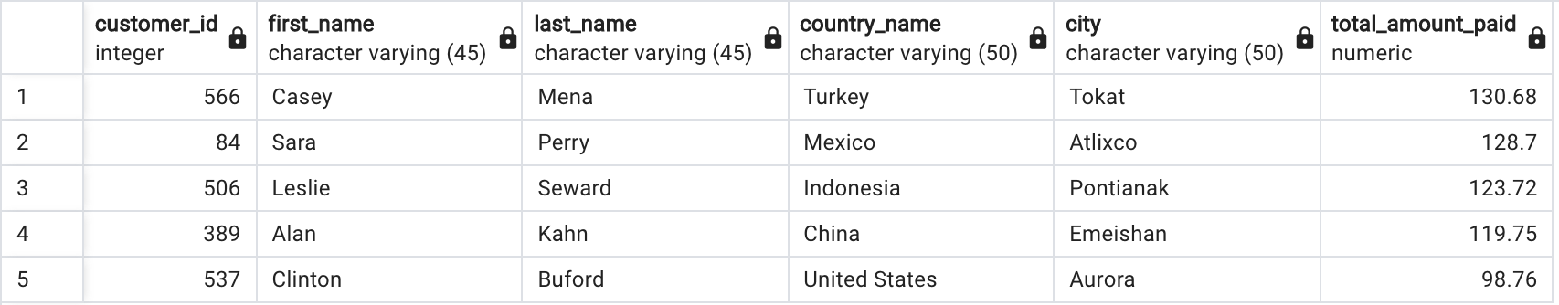

thoughts:

⇒ I used the query from number two

⇒ I had to get details about the customer payments so INNER JOINED the payment table.

⇒ based on the SUM of payments that the customer made I ordered the customers from highest amount paid to lowest

⇒ The last step was to set the limit to 5 since we only wanted the top 5

⇒ The only thing that surprises me is that my results differ from those you provided in your message. I double-checked my query but couldn't see any variations.